DAY 7

CLASS EXERCISE 3

@PostMapping("/api/door")

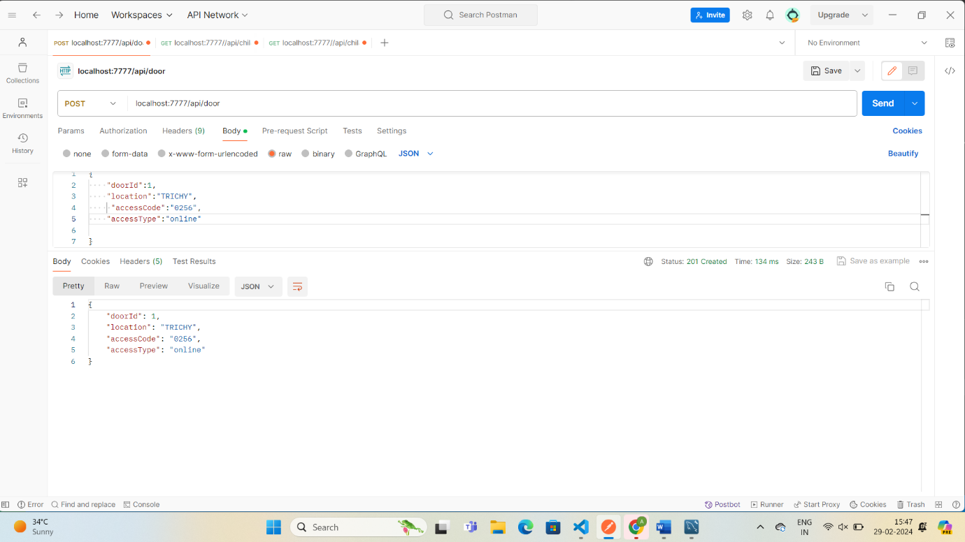

 @GetMapping("/api/door")

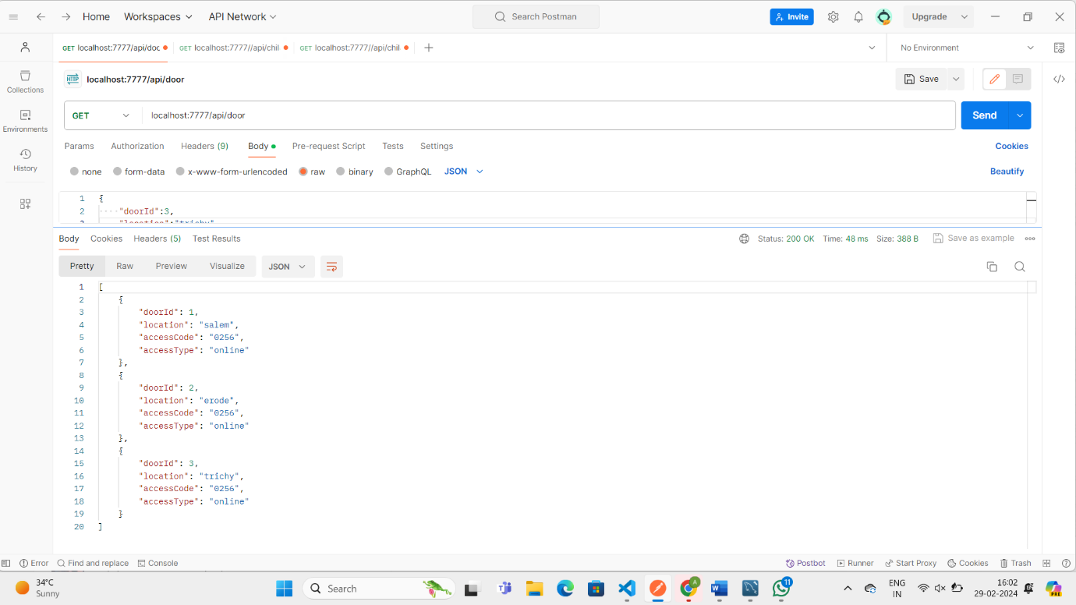

 @GetMapping("/api/door/{doorId}")

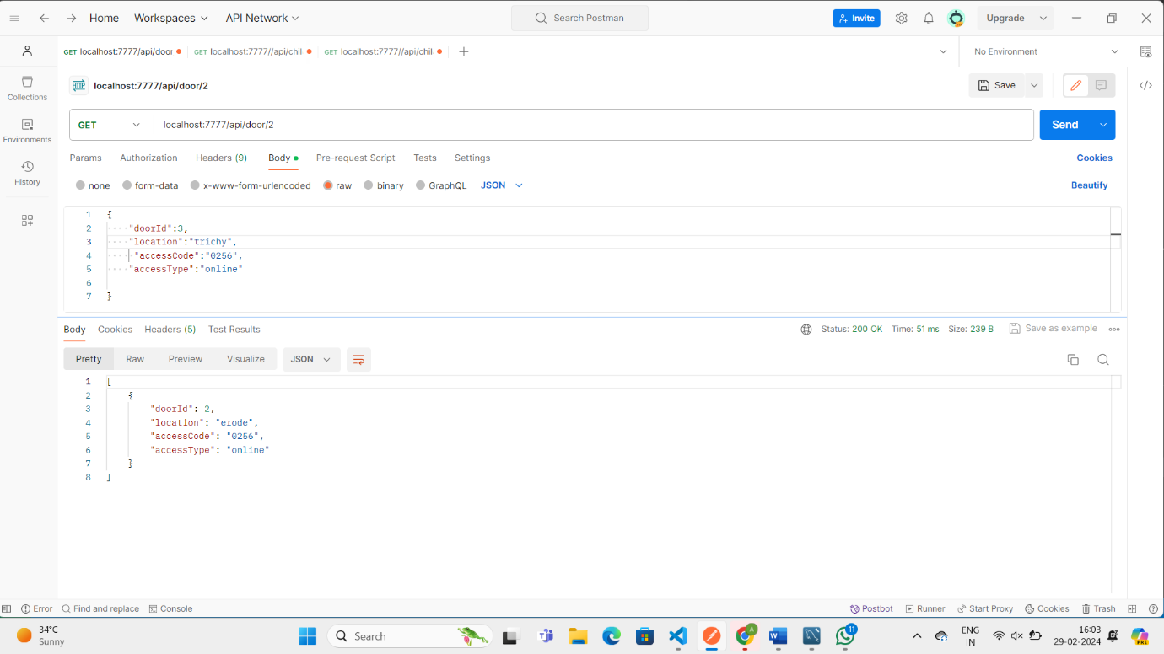

 @GetMapping("/api/door/accesstype/{accessType}")

